Tushar Balarajan  
CSC 200 (036N)  
Professor Shaban  
Programming Assignment #2

**Problem Statement:**

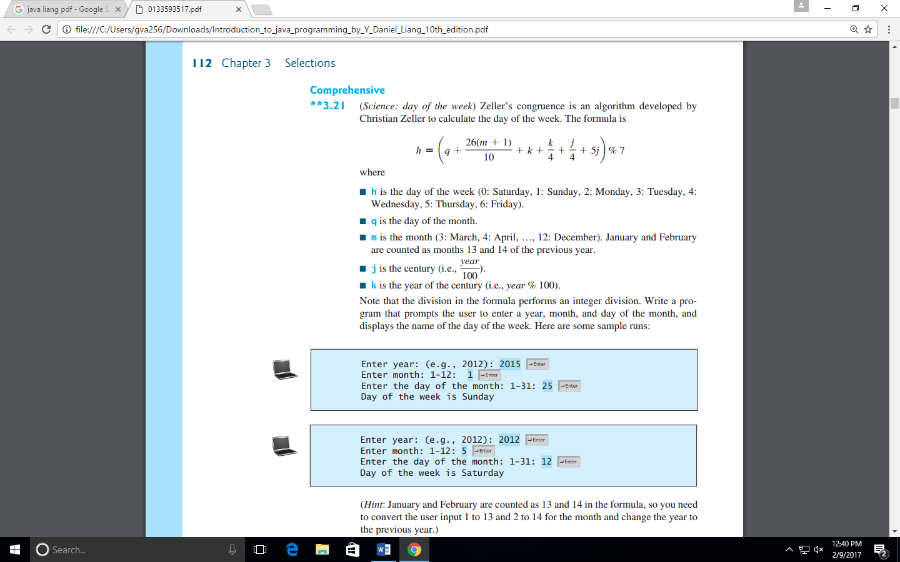

**Pseudo Code:**

START  
 YEAR ← INPUT  
 MONTH← INPUT  
 DAYOFMONTH ← INPUT

IF (MONTH < 3)

MONTH← MONTH + 12  
 YEAR← YEAR - 1

ENDIF

CENT ← YEAR / 100  
 YEARCENT ← YEAR % 100

DAY ← ((DAYOFMONTH+((26*(MONTH+1))/10)+(YEARCENT/4)+(CENT/4)+(5*CENT))%7)

SWITCH (DAY)

CASE 0:  
 OUTPUT “SATURDAY” BREAK;

CASE 1:  
 OUTPUT “SUNDAY” BREAK;

CASE 2:  
 OUTPUT “MONDAY” BREAK;

CASE 3:  
 OUTPUT “TUESDAY” BREAK;

CASE 4:  
 OUTPUT “WEDNESDAY” BREAK;

CASE 5:  
 OUTPUT “THURSDAY” BREAK;

CASE 6:  
 OUTPUT “FRIDAY” BREAK;

DEFAULT BREAK;

ENDSWITCH

STOP

**Source Code:**

package zellerscongruence;

//@author Tushar Balarajan

import javax.swing.*;

public class ZellersCongruence {

public static int Equation(int y, int m, int dm, int c, int yc){

int d = ((dm + ((26 * (m + 1))/10)+ yc + (yc/4) + (c/4) + (5*c))%7);

return(d);

}

public static String output = "";

public static void main(String[] args) {

int year = Integer.parseInt(JOptionPane.showInputDialog("\nEnter year: (e.g., 2012): "));

int month = Integer.parseInt(JOptionPane.showInputDialog("\nEnter month: 1-12: "));

int daymonth = Integer.parseInt(JOptionPane.showInputDialog("\nEnter the day of the month: 1-31: "));

if (month < 3){

month = month + 12;

year = year - 1;

}

int century = year / 100;

int yearofcentury = year % 100;

int day = Equation(year, month, daymonth, century, yearofcentury);

switch (day){

case 0 : output ="\nDay of the week is Saturday.";

break;

case 1 : output ="\nDay of the week is Sunday.";

break;

case 2 : output ="\nDay of the week is Monday.";

break;

case 3 : output ="\nDay of the week is Tuesday.";

break;

case 4 : output ="\nDay of the week is Wednesday.";

break;

case 5 : output ="\nDay of the week is Thursday.";

break;

case 6 : output ="\nDay of the week is Friday.";

break;

default : output ="\nSomething went wrong!!!";

break;

}

JOptionPane.showMessageDialog(null, output);

}

}

**Output:**

